Name: ________________
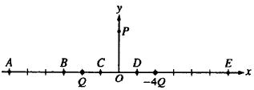
Homework Questions
Electric Forces and Fields #2
Multiple Choice Practice

Particles of charge Q and -4Q are located on the x-axis as shown in the figure above. Assume the particles are isolated from all other charges.

- Which of the following describes the direction of the electric field at point P ?

(A) +x (B) +y (C)-y
(D) Components in both the -x- and +y-directions
(E) Components in both the +x- and -y-directions

- At which of the labeled points on the x-axis is the electric field zero?

(A) A (B) B (C) C (D) D (E) E

Free Response Practice
- In the figure below (q₁ = -2.6 µC, q₂ = 6.00 µC), determine the point (other than infinity) at which the electric field is zero.
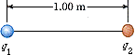
m to the left of q1

- A proton accelerates from rest in a uniform electric field of 610 N/C. At some later time, its speed has reached 1.10 10⁶ m/s (nonrelativistic, since v is much less than the speed of light).
  - Find the acceleration of the proton.
m/s²
  - How long does it take the proton to reach this speed?
s
  - How far has it moved in this time?
m
  - What is its kinetic energy at this time?
J
*Note: Remember those tough integrations we did for moments of inertia? And how we really never tested you on those, but we needed them to build enough knowledge to teach you the parallel-axis theorem shortcut? The next two problems will be a lot like those. Do what you can!

- A rod of length L has a uniform positive charge per unit length and a total charge Q. Calculate the electric field at a point P that is located along the long axis of the rod and a distance a from one end.
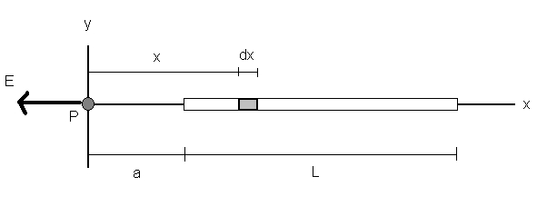
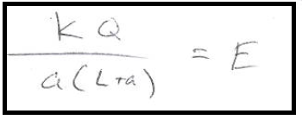

- A disk of radius R has uniform surface charge density σ. Calculate the electric field at a point P that lies along the central perpendicular axis of the disk and at a distance x from the center of the disk.
